**Class 3 Spring Term Newsletter**

**Miss Latham**

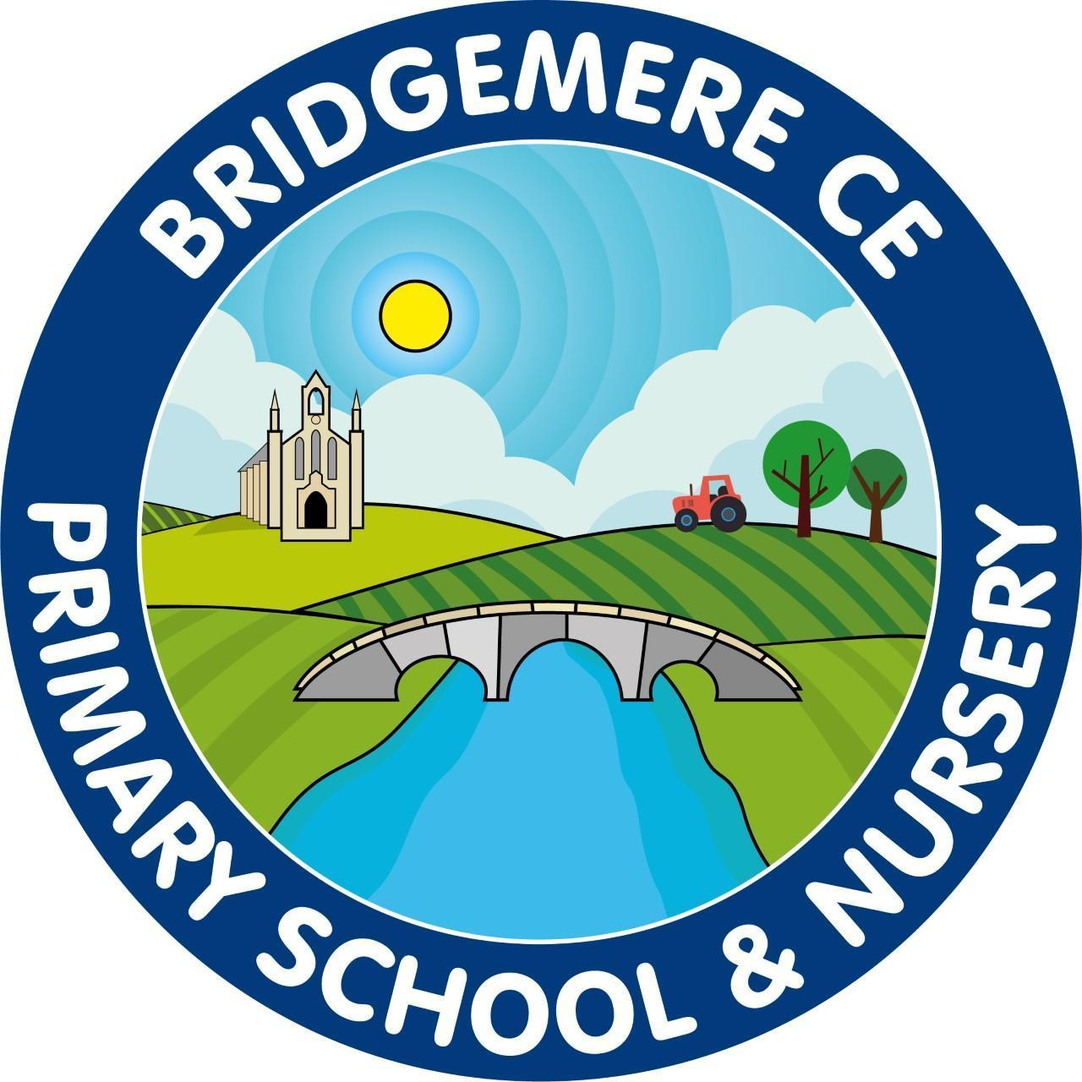

Dear Parents,

Happy New Year! I hope you’ve all had a lovely Christmas holiday and have been able to spend time with friends and family.

**Reading**

In Class 3 we continue to use Accelerated Reader to maintain and enthuse our brilliant readers. This will require your child to read every day for a minimum of 15 minutes as compulsory. When books are read and understood fully;even if this means reading smaller books twice, your child will complete an online comprehension test. We strive for your children to do their best, however we do have an expectation of understanding a text with a minimum of 80% accuracy.

In Key Stage Two we love competition, so Class 3 and Class 4 each week will compete to see how many books each class can read with rewards of team points and additional Class choice time on a Friday.

Last term I was extremely proud of our class, as we had more than half the class reaching their reading targets. We aim to keep this success this term!

**English**

During our English learning this term we will focus on including our grammatical language and skills when writing information, narrative and other fictional and non-fictional written pieces. As a class we continue to work on our handwriting and presentation: not only to produce beautiful work but these can also dramatically change our individual outcomes.

During Writing we will be using the text ‘Egyptology’ by Dugold Steer where we will use our narrative skills to create mystery stories.

**P.E**

PE lessons will be on a Tuesday and Thursday for this half term. On Tuesday we will be focusing on Dance and Thursday will be Gymnastics. Netball and basketball will follow in the second half of Spring term.

Please make sure your child has the correct PE kit on for these days, our branded kit or plain black clothing.

Please make sure your child’s PE kit and school uniform are clearly labelled. These items need to have names in their labels. You’ll be surprised how many items still go missing even when they are wearing them.

**Other learning**

This term our foundation learning will be ‘The Ancient Egyptians’ where we will practise our historical and geographical skills linking these to our previous knowledge and understanding of Ancient civilisations and Through the Ages.

We will look at significant events and timelines to further understand impacts of the past on our lives today.

To support this learning, Class 3 will take part in Egyptian day on Monday 3rd February within school.

In Science we will be focusing on Living things and their habitats and plants. In RE we will deepen our knowledge of Jesus and compare our knowledge within multi-faiths.

If you have any concerns or questions at all please use communication diaries as these will be checked daily or ring the office to arrange a meeting.

**Kind Regards**

Miss Latham