**Bridgemere CE Primary School – KS2 Data 2023 & 2024**

Progress and attainment charts: Key Stage: **Reading, writing and mathematics – 2023:**

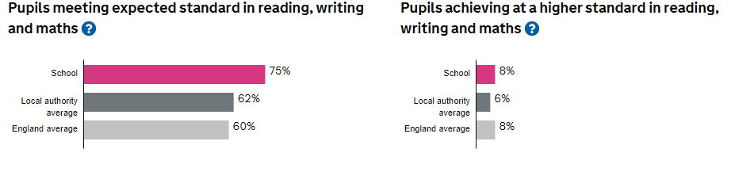

Progress and attainment charts: Key Stage: **Reading, writing and mathematics – 2024:**

|  |  |  |  |  |
| --- | --- | --- | --- | --- |
| **Teacher Assessments** | | | | |
|  | **Reading** | | **Writing** | |
| **Result** | **School** | **National** | **School** | **National** |
| **GDS** | - | - | 11 | 13 |
| **EXS** | - | - | 78 | 58 |
| **WTS/HNM** | - | - | 11 | 22 |
| **PK6** | 0 | - | 0 | 3 |
| **PK5** | 0 | - | 0 | 2 |
| **PK4** | 0 | - | 0 | 1 |
| **PK3** | 0 | - | 0 | 0 |
| **PK2** | 0 | - | 0 | 0 |
| **PK1** | 0 | - | 0 | 0 |
| **EM** | 0 | - | 0 | 0 |
| **A** | 0 | - | 0 | 0 |

GDS is awarded if the pupil is working at greater depth at the expected standard.

EXS is awarded if the pupil is working at the expected standard.

WTS is awarded if the pupil is working towards the expected standard.

|  |  |  |  |  |  |  |  |  |
| --- | --- | --- | --- | --- | --- | --- | --- | --- |
| **TEST RESULTS** | | | | | | | | |
|  | | **Percentage at outcome** | | | | | | |
|  | | **B** | **NS** | **AS** | **HS1** |  | **U** | **A** |
| **Grammar Punctuation & Spelling\*** | **School** | 0 | 11 | 56 | 33 |  | 0 | 0 |
| **National** | 4 | 23 | 42 | 30 |  | 0 | 0 |
| **Reading** | **School** | 0 | 11 | 56 | 33 |  | 0 | 0 |
| **National** | 4 | 23 | 44 | 29 |  | 0 | 0 |
| **Mathematics** | **School** | 0 | 11 | 44 | 44 |  | 0 | 0 |
| **National** | 3 | 23 | 49 | 24 |  | 0 | 1 |

NS is awarded if the pupil has Not Achieved the Standard.

AS is awarded if the pupil has Achieved the Standard without a High Score.

HS is awarded if the pupil has Achieved the Standard with a High Score.

*Pupils meeting expected standard in reading, writing and maths: 89%*

*Pupils achieving at a higher standard in reading, writing and maths: 11%*

*‘The school has high expectations of what pupils can achieve, most pupils rise to meet these high standards. Typically, pupils achieve well. They are well prepared for the next stage of their education.’*