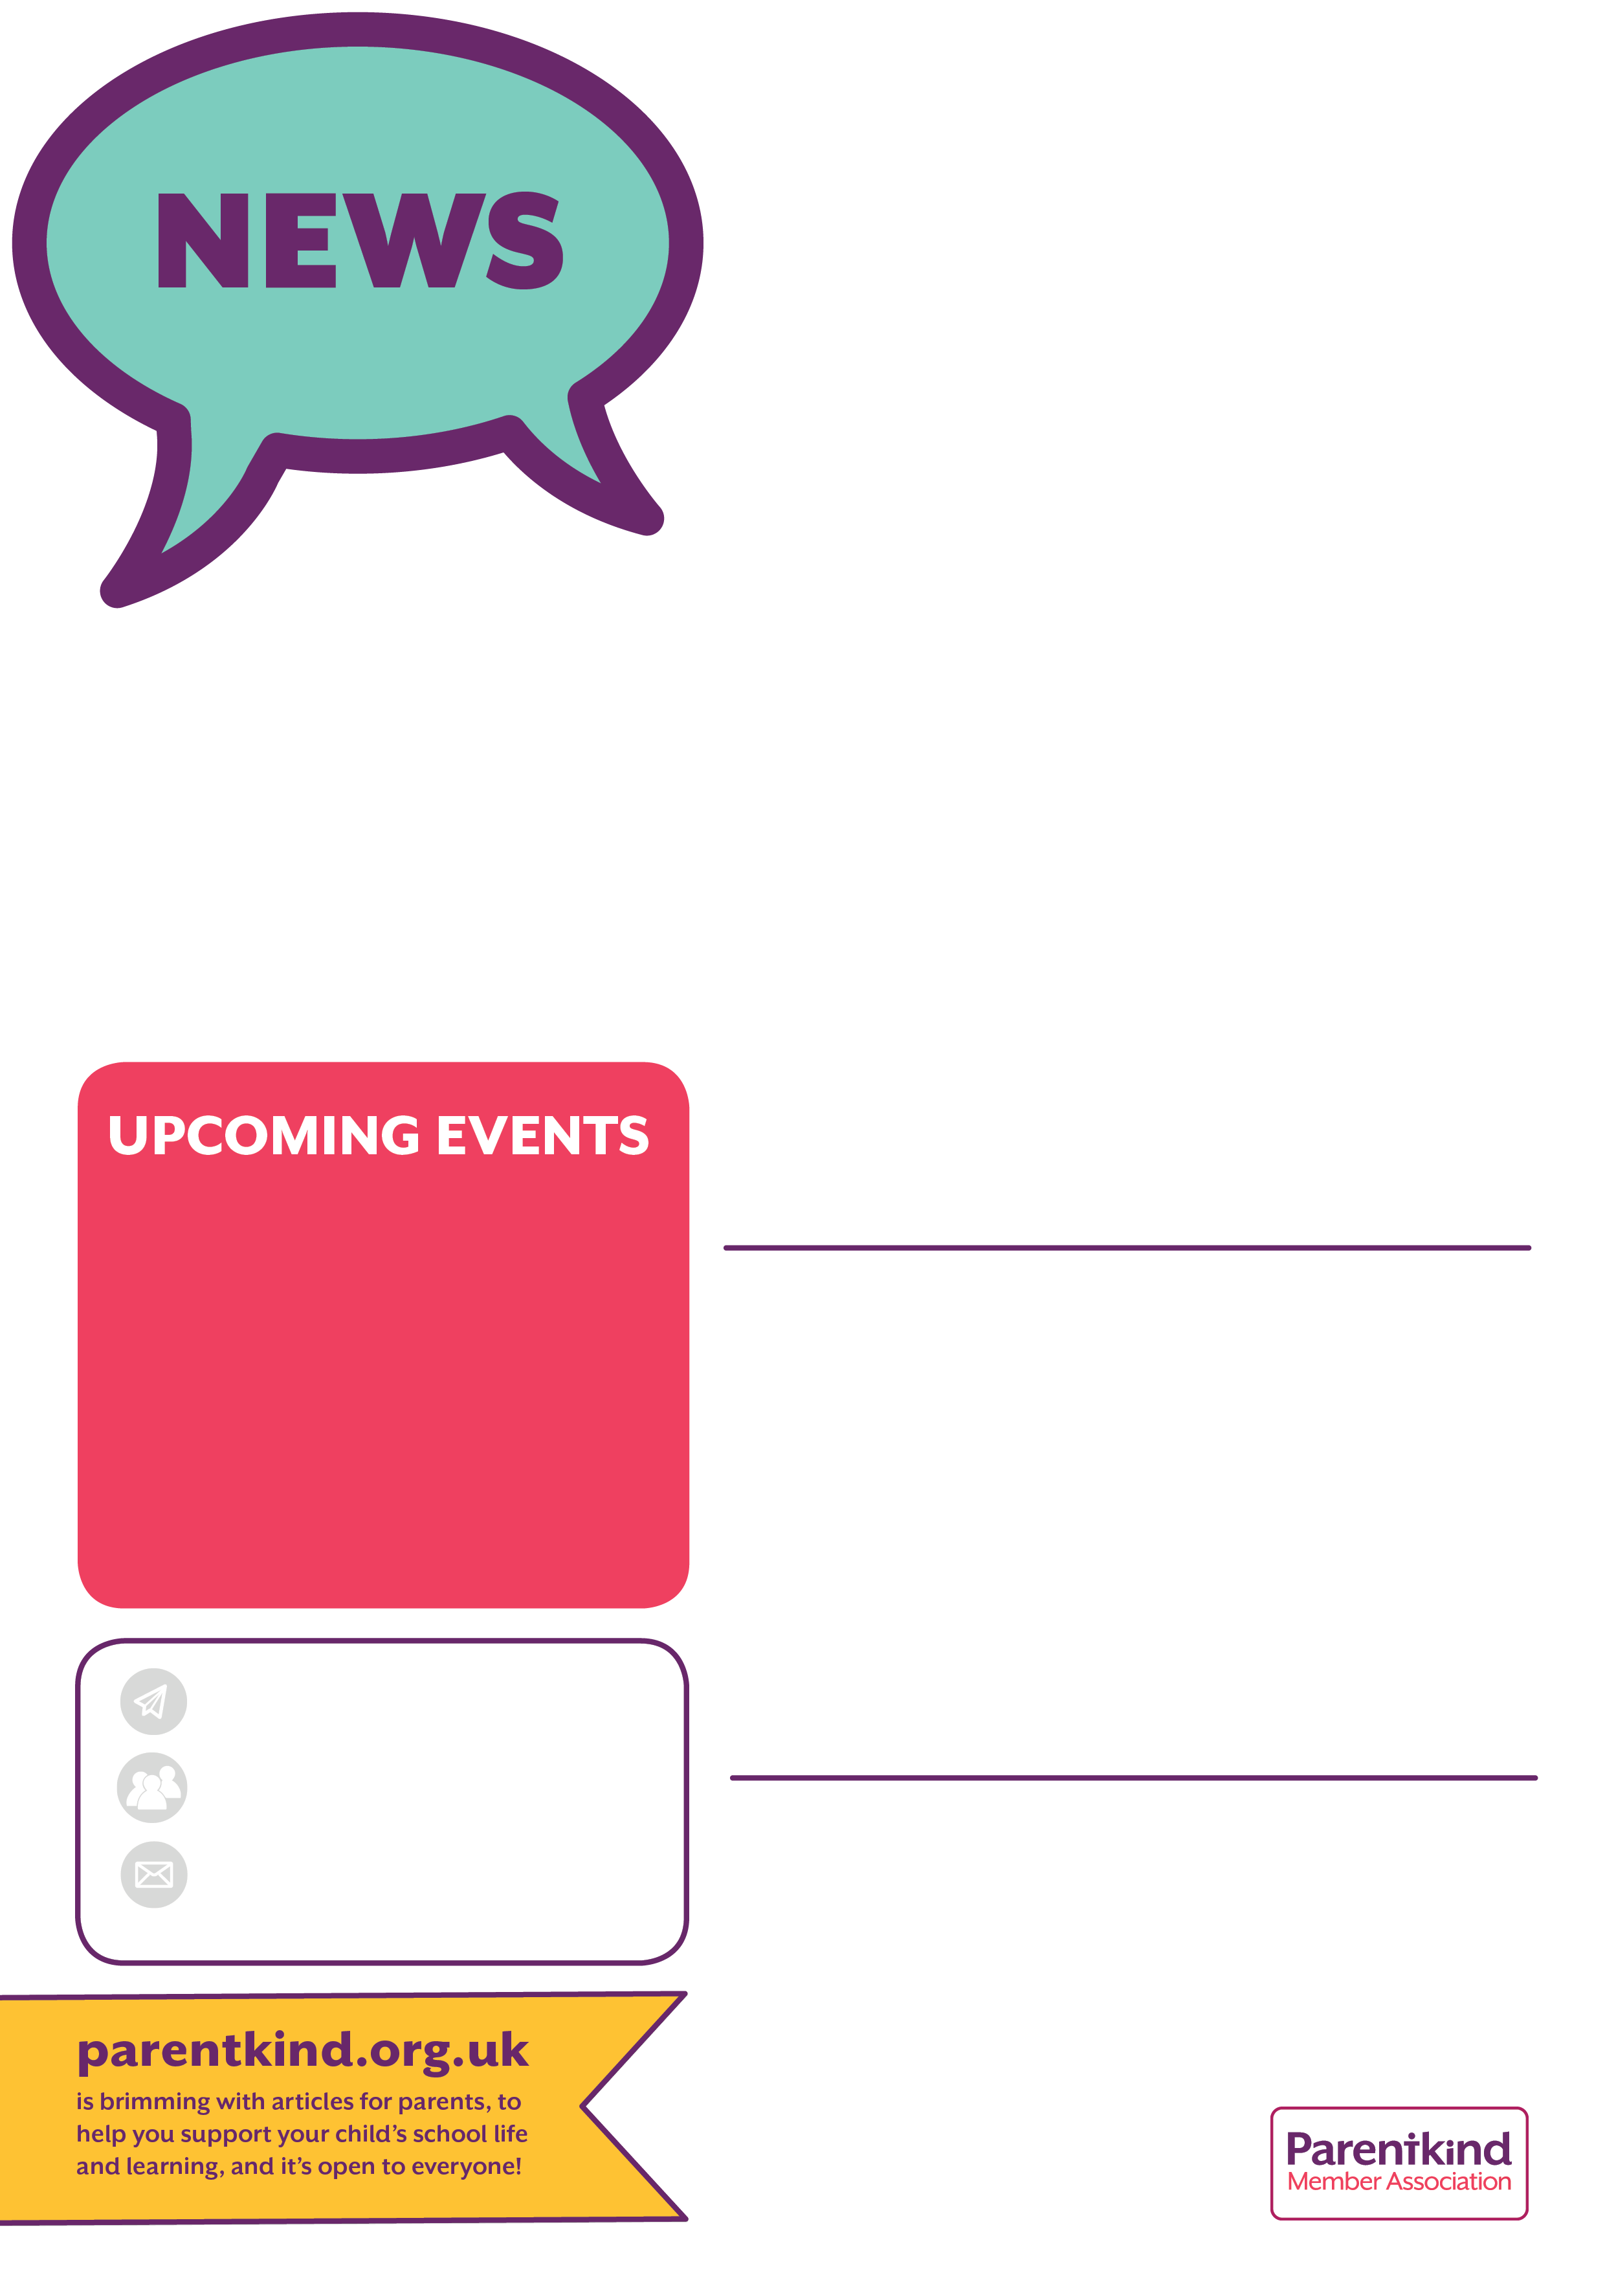

**Easter Bingo!**

**Easter Hamper Raffle**

For the chance to win a lovely hamper filled with “*Egg*-citing” Easter goodies, please buy a raffle ticket £1 each.

Anyone can enter! The draw will take place at Easter Bingo.

Payments in cash to the School Office or by bank transfer to the “Friends of Bridgemere School” sort code: 54-10-17 Account number: 10724826.

Our Easter Bingo is on Wednesday 29th March, in School 3:30pm - 4:30pm for the children only to take part in.

It’s £2 per child. Payments in cash to the School Office or by bank transfer to our FOB bank account (details below).

Your child will given a bingo card and

pencil. And the chance to win some

yummy chocolate Easter Eggs!

Parent / carer helpers needed please.

Non-Uniform Day in exchange for

Chocolate Easter Eggs: Friday 24th

Would your children like to buy a pretty primrose plant to give to Mum, Granny or a favourite Aunty on Mother’s Day?

We’re selling personalised plants for £2 per plant or 3 plants for £5 (cash only) on Friday 17th March

at School, 3:15pm.

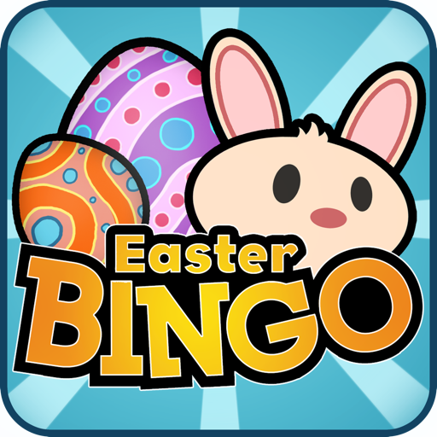

**MARCH**

**Friday 17th**

**Friday 24th**

**Wednesday 29th**

**2023**

**Mother’s Day Gift Sale**

**Non Uniform Day in exchange for chocolate Easter egg**

**Easter Bingo &**

**Easter Hamper Raffle draw**

**We’re a group of parent and staff volunteers, who give their time to create better learning experiences for our school children.**

**As well as raising much-needed funds that improve our school, the social events that we run bring the whole school community together to have some fun!**

**Anyone can help. We’re particularly looking for parents of children in Key Stage 1 to help with our events. If you’re able to help in any way, big or small, please speak to us or the School Office.**

**Friends of Bridgemere School (‘FOB’)**

Chair – Still wanted!

Secretary - Emma Minshall & Kristen Bahry-Webber

Treasurer – Sarah Furber

Facebook page:

Friends of Bridgemere





**Mother’s Day Gift to Buy**

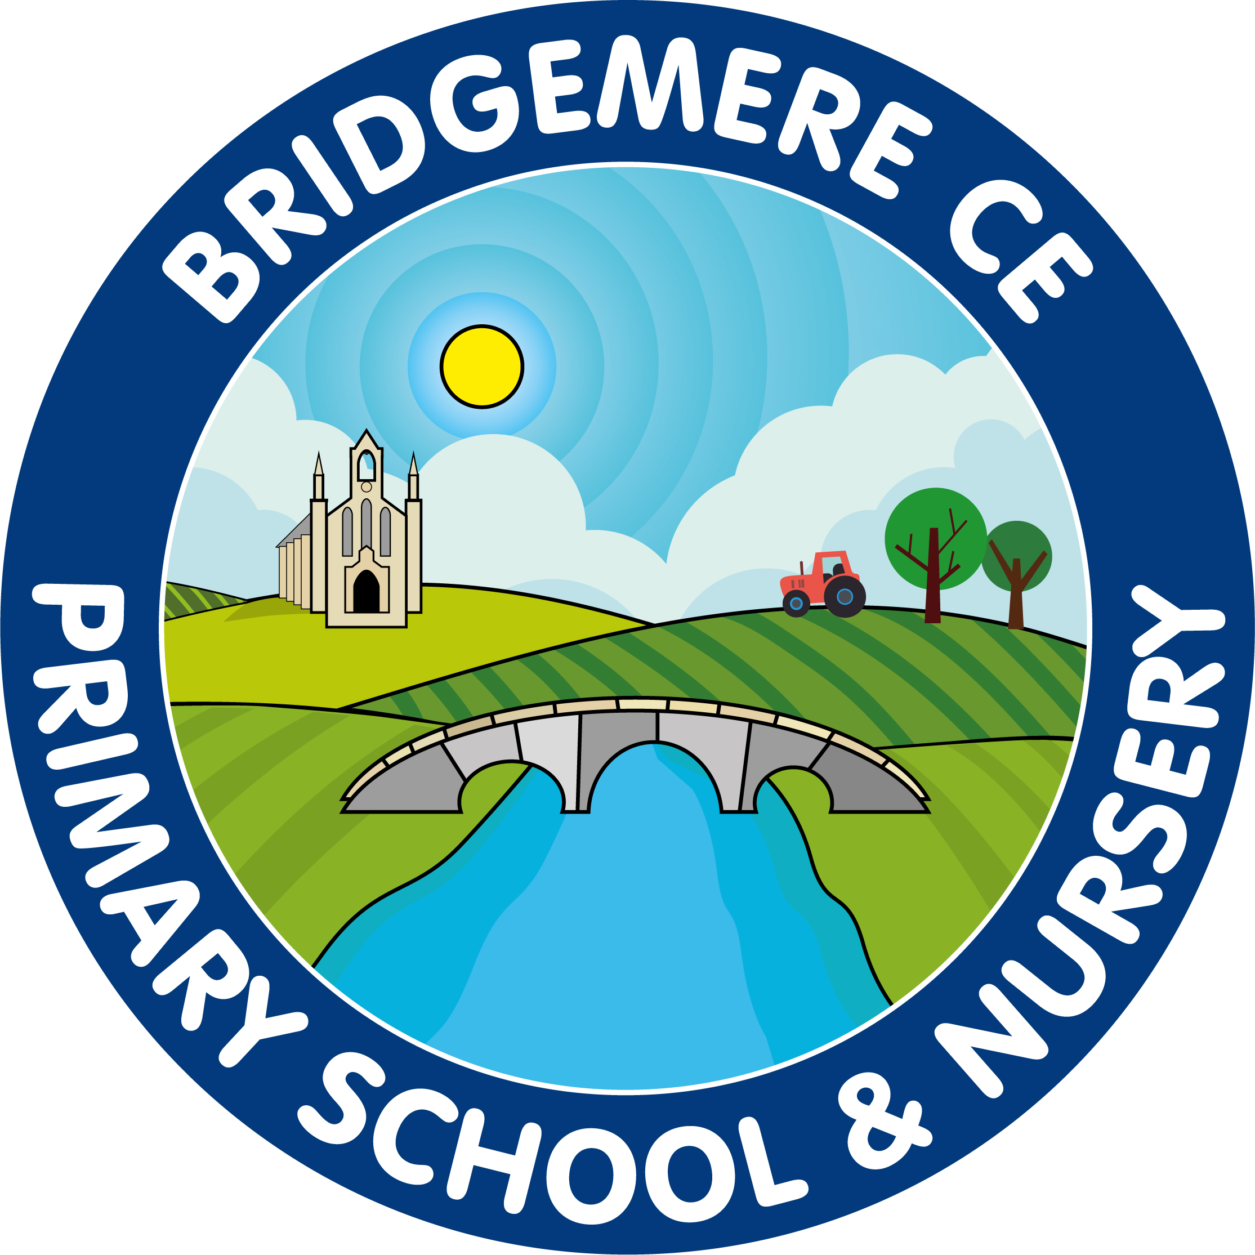

**SPRING ISSUE 2023**