Bridgemere CE Primary Newsletter  ‘I can do all things through Christ who strengthens me’  Philippians 4v13 December 2022 |  |  | 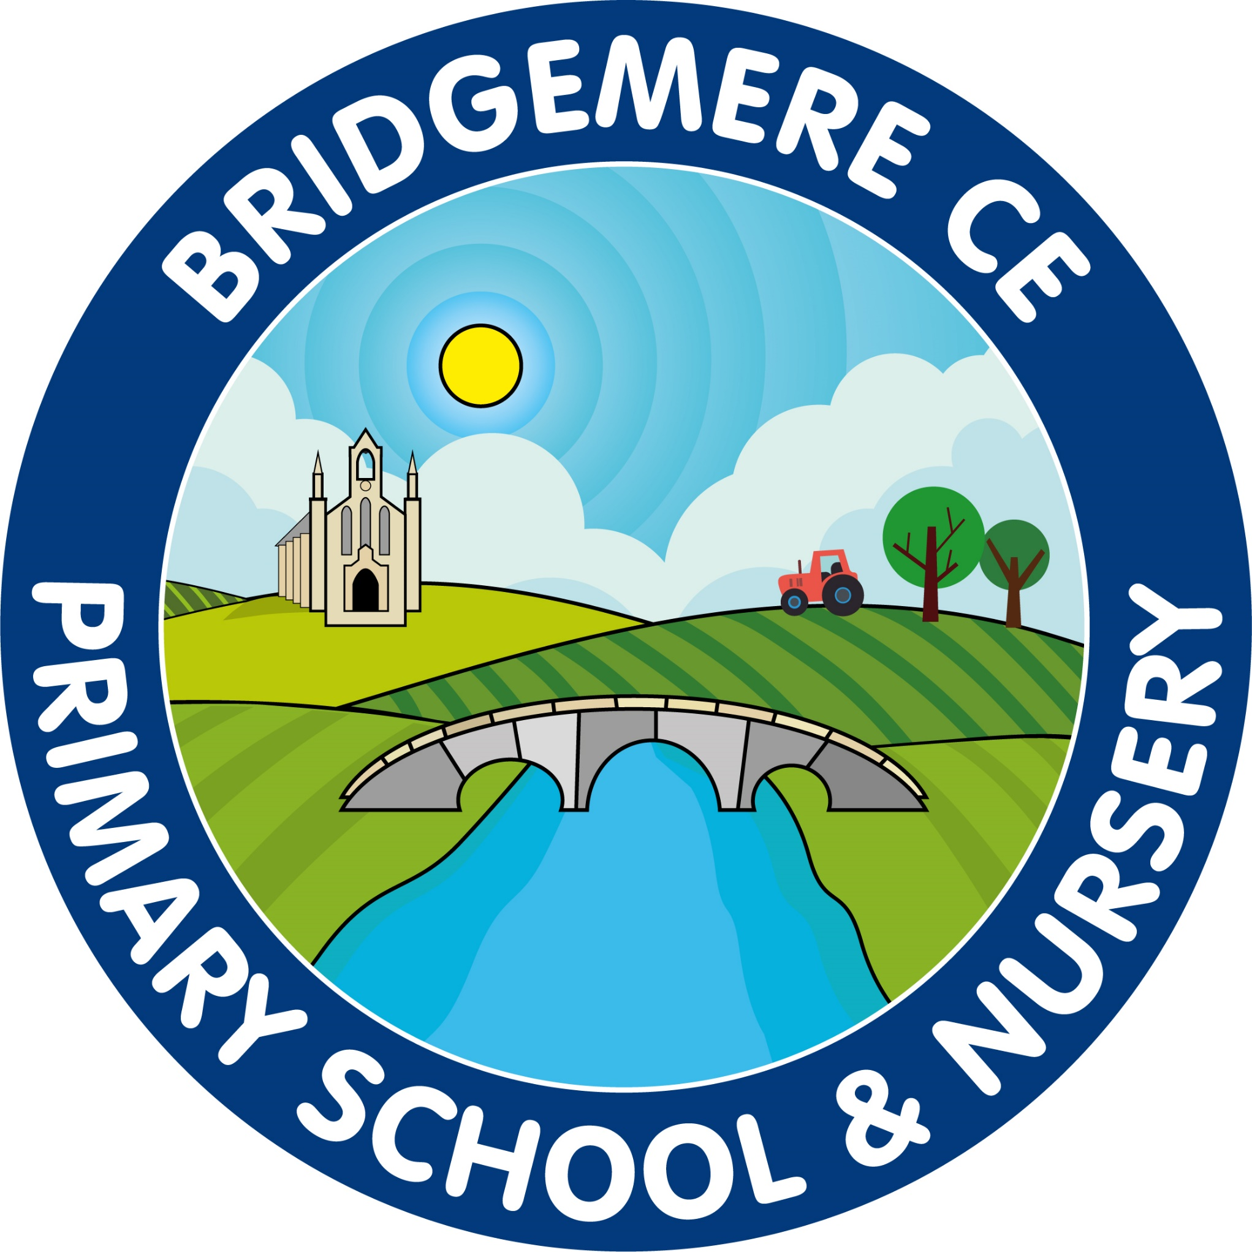  Dates coming up:  Monday 5th December-  Miss O’Leary starts in Class 4  Friday 9th December – Stay & Play 9.00-10.15am  Non-uniform day for tombola prizes  Tuesday 13th December – Nativity – Class 1 & 2  2pm  Wednesday 14th December – Nativity – Class 1 & 2  5pm  Thursday 15th December – KS2 Carol Service at St John’s Doddington 1.45pm  Friday 16th December-  Panto Trip to see Peter Pan at The Regent – Hanley  Monday 19th December – Elf Run for St. Luke’s Hospice  Christmas Fair 3.15pm  Wednesday 21st December – Christmas Party & Christmas Dinner Day  End of term  Tuesday 3rd January – Inset Day  Wednesday 4th January – School opens
Can you believe we are in the month of December! As there is so much going on this month I thought we would get the newsletter to you early so you can make sure you have all the dates in your diary.  Nativity  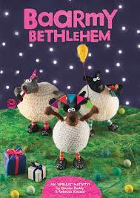  Class 1 and 2 are very excited about their Natvity this year ‘Baarmy Bethlehem’. The performances will take place on the afternoon of Tuesday 13th December at 2pm and Wednesday 14th December at 5pm.  A letter will be sent out attached to this newsletter for parents of Class 1 & 2.  KS2 Carol Service    The KS2 Carol Service will take place at St. John’s Doddington on Thursday 15th December at 1.45pm, everyone is welcome.  We will aim to leave school just after 1pm giving us time to walk to the church.  If there are any parents who would like to walk with us please could you let the office know. Thank you.  Elf Run  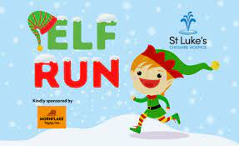  Before the Christmas Fair on Monday 19th the children will be taking part in the Elf Run in aid of St Luke’s Cheshire Hospice. We have tried to keep fund raising to a minimum this year due to the current financial climate but feel the hospice does so much to support local people with life limiting illnesses. A sponsor envelope will be attached to this letter for all children. | ‘Friends of Bridgemere’  Christmas Fair    The Christmas Fair will take place on Monday 19th December at school from 3.15pm.  The choir will open the fair and like last year we are hoping to host it outside, weather permitting!  Once again there will be lots of great stalls to visit and games to play, we look forward to seeing you there.  Our recent sweets sale raised £56! In addition, our Halloween Party raised a spooktacular £362!  A big thank you to everyone who helped and attended.    Is taking place on Friday 9th December. Please can your child(ren) bring in a tombola prize for the Christmas Fair. Thank you.  Paternity Cover – Class 3    Mrs Lock will be covering Class 3 while Mr Lyons takes his paternity leave in January. We will keep you posted with the dates and of course of the exciting news of the new arrival.  As always, if you have any concerns or queries regarding your child’s education, please do not hesitate to contact me.  Caroline Middleton  Head Teacher

