**Class 2 Spring Term Newsletter**

**Mrs Banister and Mrs Strefford**

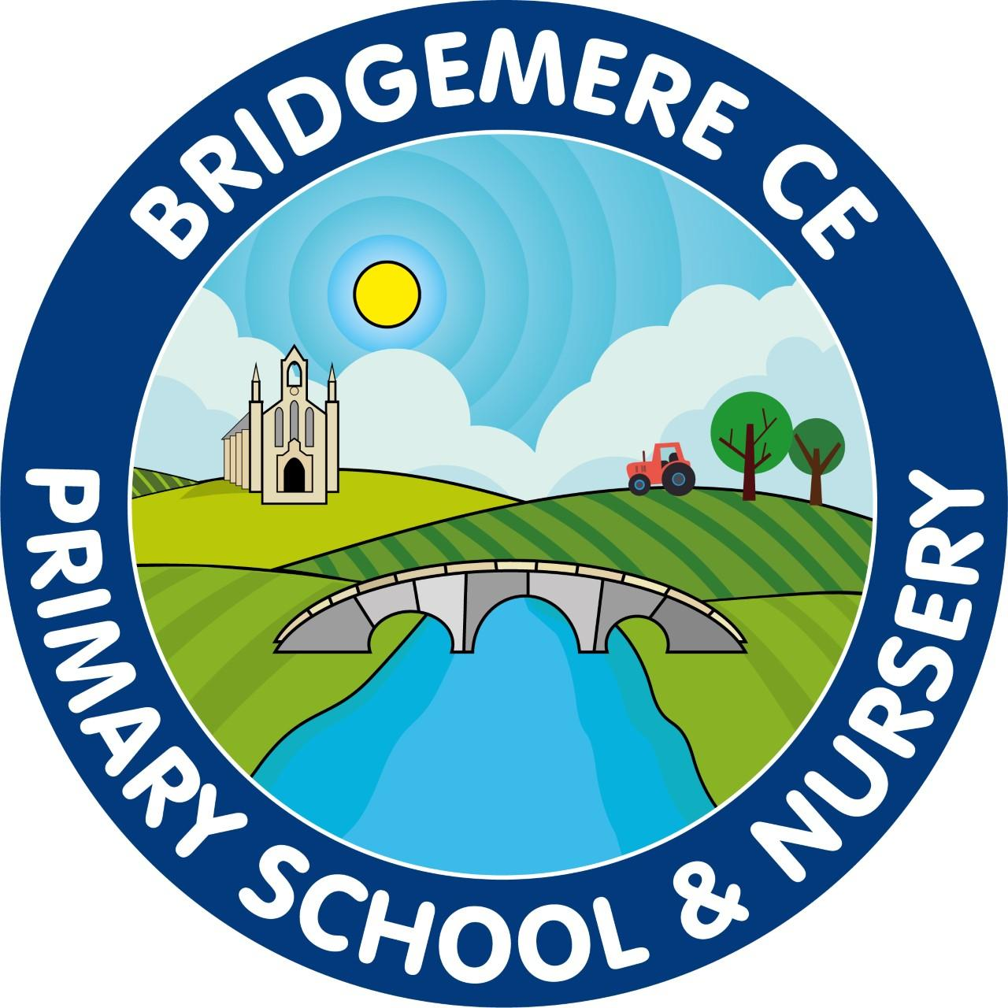

Dear Parents,

We hope you’ve all had a relaxing yet festive Christmas holiday with your families and are ready to take on 2025. We’ve made an amazing start to our school year and I’m so excited for our spring term!

This term we will be joined by Miss Winward who will be completing her final year teaching placement in our class.

**Phonics and Reading**

We will be continuing to use Read, Write, Inc to support your child with their reading and spelling each morning.

Each week, we will continue to send your child home with books from RWInc scheme on Tuesdays and Fridays. It is important that these are read at home each day for 10-15 minutes and this is recorded in the communication diary. Books may not be changed if they are not being read at home.

You may find your child is bringing books home that they may have previously read, this is because children are assessed every half term on their progress and may need to build confidence in fluency and understanding and therefore repeating books is the best and most efficient way we can do this.

It is really important to support your children at home with phonics alongside their school learning. All phonics sounds are found in their communication diaries and we will continue to send links home to RWInc videos that will support your child’s phonic knowledge.

**Maths**

Year 1s – We will continue to develop our knowledge of numbers specially to 50 this term. The children will practice ordering, comparing, adding and subtracting within 50 before identifying 2d and 3d shapes.

Year 2s – We will begin the term by looking at division specifically dividing by 2, 5 and 10. Next, we will move away from calculations and begin looking at measurement of length, temperature and weight.

**Curriculum**

This term our learning is all focused on the questions, ‘Is the United Kingdom the same all over?’ The children will be looking the countries and their capital cities that make up the United Kingdom as well as the seas surrounding our amazing country. We will be identifying England, Northern Ireland, Scotland and Wales on a map before we look at similarities and differences in their landscapes.

In science, we will be learning about people and their pets and how we look after different animals before looking closely habitats and food chains. We may even try growing some of own foods!

**PE**

PE lessons will continue to be on a Monday and **Tuesday**. This term is very exciting as we have a dance specialist coming to teach us every Tuesday! Please make sure your child’s kit in is school and has appropriate PE clothes on the days named above.

If you have any concerns or questions please use your child’s communication diary as this will be checked daily or ring the office to arrange a meeting.

**Kind Regards**

Mrs Banister and Mrs Strefford