Bridgemere CE Primary  ‘I can do all things through Christ who strengthens me’  Philippians 4v13 Autumn Term 2024 20232023 |  |  | 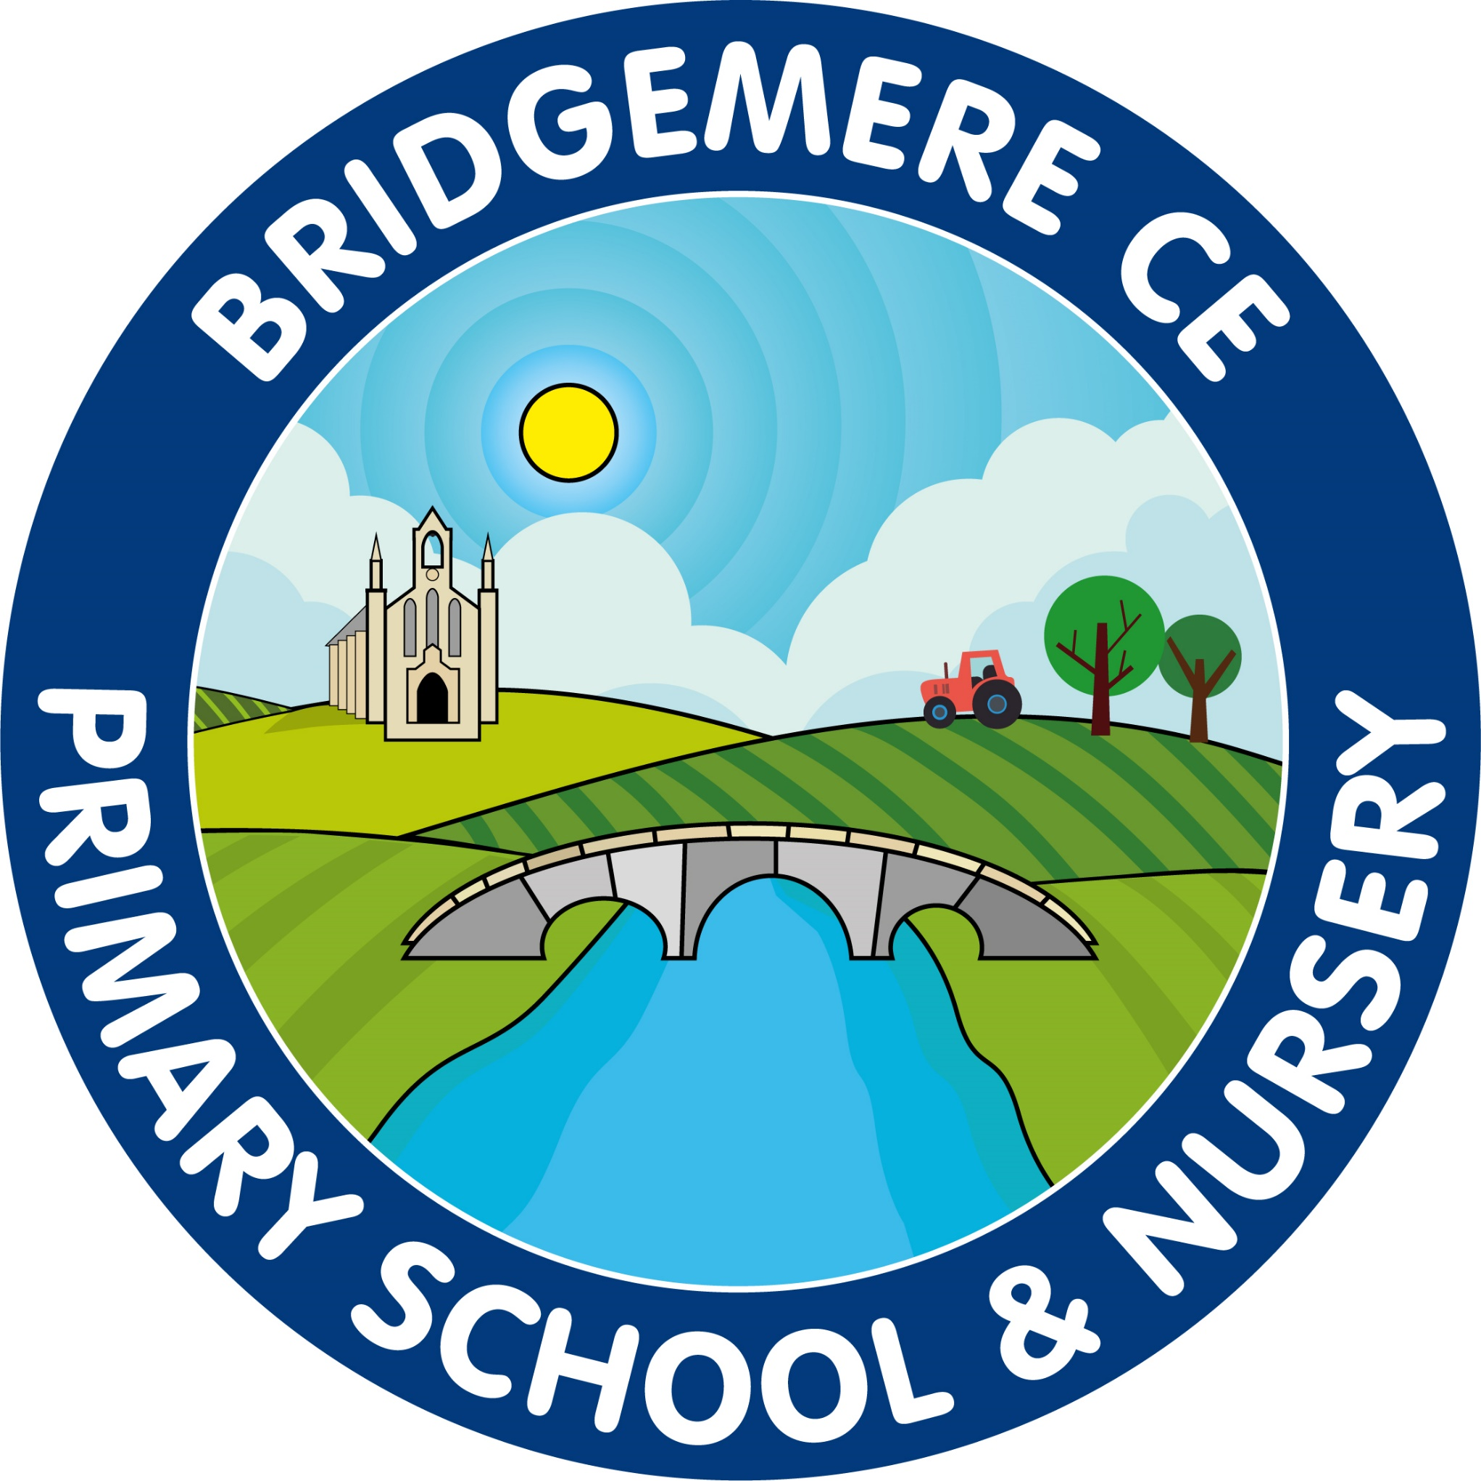
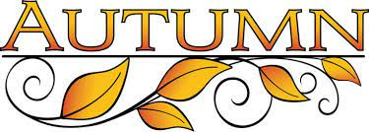  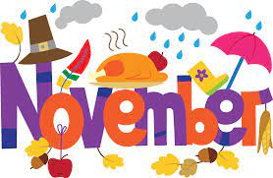  Return to school  Monday 4th November  Bonfire themed school lunch  Tuesday 5th November  Parents’ Meetings  Tuesday 5th November – online  4-6pm  Wednesday 6th November – in school 3.30-7pm  ‘Stay & Play’  Wednesday 13th November 9.00-10.15am  Book Fair  Thursday 14th November – 21st November  Parent Council Meeting  Monday 18th November – 6pm |   Christmas Dinner Day -  Friday 6th December  Elf Run Day –  Friday 6th December  Non-Uniform day – for Tombola Prizes for Christmas Fair  Friday 6th December  Nativity – Class 1 & 2  Tuesday 10th December 2pm  Nativity – Class 1 & 2  Wednesday 11th December 5pm  KS2 Carol Service –  Wednesday 11th December at St John’s Doddington 2pm  ‘Stay & Play’  Friday 13th December 9.00-10.15am  Friends of Bridgemere – Christmas Fair  Friday 13th December 3.30-5.00pm  Whole school Panto visit – Northwich  Tuesday 17th December  Christmas Parties  Break up for Christmas –  Thursday 19th December

