Year 5/6 Autumn Term Newsletter
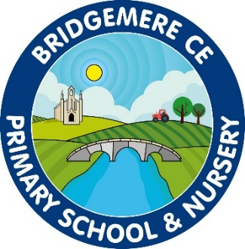
Dear Parents,
I hope that you have all had a lovely summer and are looking forward to the year ahead. The children have already made a great start over the first few days and I am sure it won’t be too long before they settle into/back into the key stage 2 way of life!

Curriculum
This half term we have a history focus, we are looking at Crime and Punishment Through the Ages. We will be investigating different crimes and their punishments during different stages of history e.g. Roman Britain and Anglo Saxon Britain.
Our English lessons this year will based on various fantastically immersive books, Hansel and Gretel by Neil Gaiman and Macbeth and Romeo and Juliet by William Shakespeare. We will be having a go at writing a short narrative, diary and a persuasive letter based on these stories. As well as these books we will also be looking at The Highwayman by Alfred Noyes to give us alternate genres of writing. Our class novel will be Holes by Louis Sachar.
In Science our topic in Autumn 1 is “Living things and their Habitats”. As part of this we will be focusing on reproduction of plants and reproduction of asexual living things. As well as this we will be exploring life cycles of insects, amphibians, birds and mammals. Our Science topic in Autumn 2 is “Materials and Their Properties”. As part of this topic we will be experimenting with sound proofing, electrical conductivity and recycling.
In RE we will be looking at Life as a journey: Is everyone’s journey the same? Advent: How do Christians prepare for Christmas? And Multi faith: Why do people of faith make pilgrimages?

Celebration of Learning
On Tuesday 22nd October at 3pm we will be inviting parents into school to come and have a look at your children’s learning so far. This will give you the opportunity to talk to your child and look through their books.

Times Tables
It is important that children are learning to recall their times tables at speed. They should be able to count up and back in their tables from 2 – 12. It is so important that they are practicing a set of tables every day to ensure that they have been fully embedded in their working memory. I will be testing the children on these once they have settled in over the next few days and times tables tests will be given every week; the challenge is for your child to try and beat their previous score.

Reading
Your child will need their reading diary in school every day. Please ensure that you record any reading that they do at home in their book. In school we shall ensure that they read for 20 minutes each day as well as a class novel and we are also asking for parents to do the same. Reading is key to children’s progress across the curriculum so anything you can do to help will have a great impact. These reading diaries will be used as a communication book between me and you; these books will be checked daily.

P.E
This term we will have P.E on a Wednesday and Friday. Please can you ensure that your child comes to school in their PE kits on these days. A PE kits consists of plain black shorts (joggers/leggings) and t-shirt (jumper) or school logo equivalents. The children will be doing lots of different activities in PE. It is imperative that your child is in the correct PE kit as this forms part of our uniform policy and adheres to health and safety. If the incorrect PE kit is worn a spare kit will be given to your child for the day. The children will be doing lots of different activities in PE which will require them to be on the field during wet conditions so a spare pair of socks is advisable.
General
Please keep an eye on the class page of the school website for up-to-date information. I will also add any class letters I write onto there in case they get lost on the way home. Please also make sure that your child has a water bottle to bring into school each day.
If you have any concerns or questions about your child’s learning please book an appointment to speak to me through the school office. I am looking forward to the year ahead!

Kind Regards

Mrs McGarrigle

