**Class 3 Autumn Term Newsletter**

**Miss Latham**

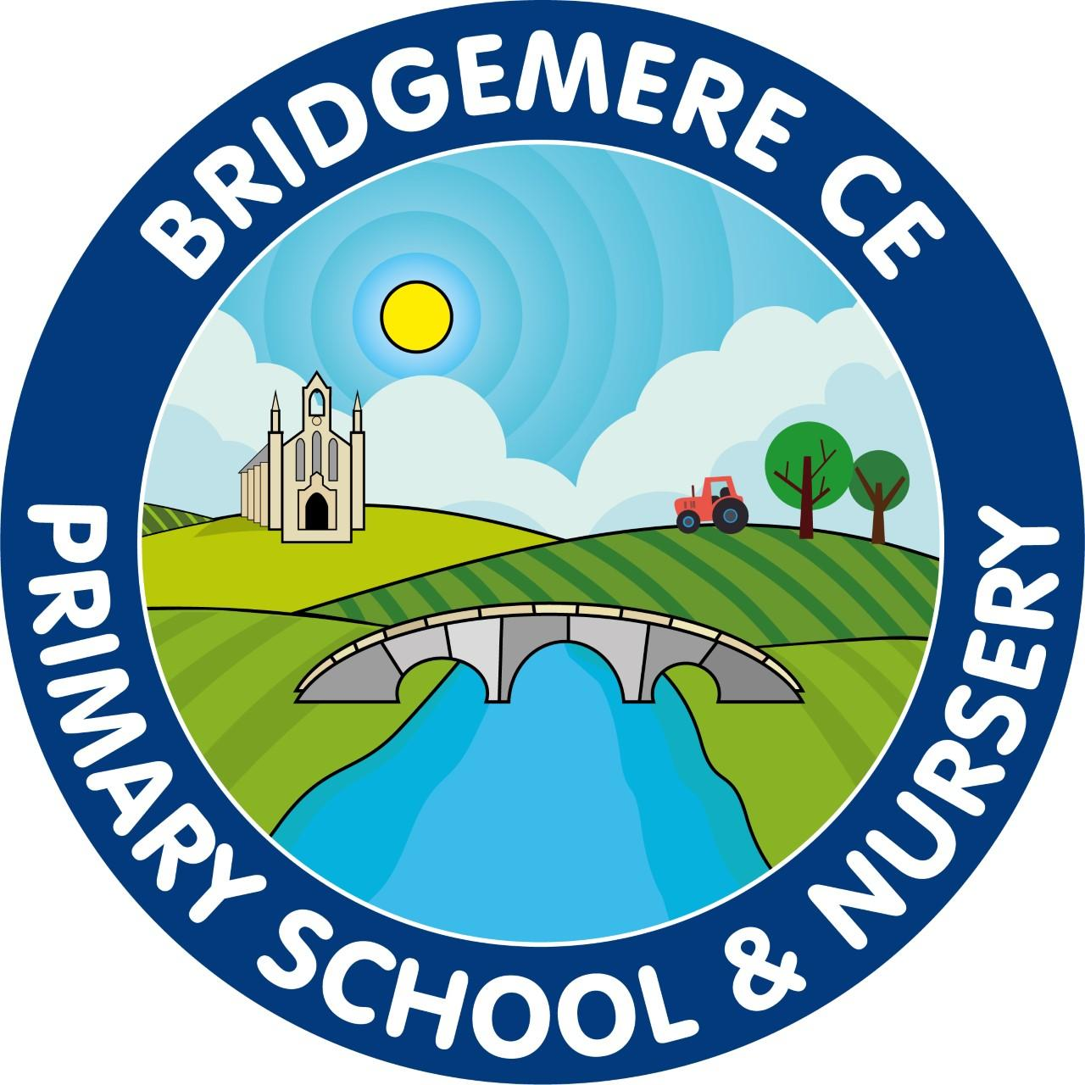

Dear Parents,

Welcome to Class 3, 2024-25! I hope you’ve all had a lovely summer holiday and you’ve enjoyed having the children back in school this week. I’m excited to have them all in Key Stage 2!

As we ease into the year with new staff and a change of Key Stage for some, Class 3 will be taught SPAG lessons by Mrs Gaffney while I support staff in Key Stage 1 with phonics and maintain the fantastic standard of Read, Write, Inc teaching and learning. As the term moves on Mrs Gaffney will begin to teach phonics and I will be able to return to teach SPAG with my own lovely class.

**Reading**

In Class 3 we use Accelerated Reader to maintain and enthuse our brilliant readers. This will require your child to read every day as compulsory in and out of school hours. When books are read and understood fully, your child will complete an online comprehension test. We strive for your children to do their best, however we do have an expectation of understanding a text with a minimum of 80% accuracy. Children will be expected to complete a minimum of 2 quiz tests each week, unless reading longer chapter books.

**English**

During our English learning this term we will focus on including our grammatical language and skills when writing narrative and other fictional and non-fictional written pieces. This will include the continuous use of Read, Write, Inc for support with spelling and discretely taught grammar and punctuation.

**P.E**

PE lessons will be on Monday and Thursday afternoons. Our focus this term will be on team sports. We will improve our teamwork and sportsmanship and our knowledge and skills of different sports.

Please make sure your child has appropriate PE clothes as our lessons will be outside as much as possible. Remember on these days your child can come into school wearing their PE kits

*Please make sure your child’s PE kit and school uniform are clearly labelled.*

**Other learning**

This term our foundation learning will be looking at comparing the North West and Naple Bay, Italy, where we will practise our historical and geographical skills. We will look at significant events and timelines to further understand these monumental events across the world. We will improve our map skills in Geography focusing on world maps. Science we will be focusing on rocks, identifying, naming and understanding how these are made and light, focussing on the presence, absence and its direction. RE we will look at David and the Psalms, discussing different values and how important they are to us.

**Homework**

Although as a school we have a no homework policy, it is important to note that we do expect your child to read for 30 minutes a day to support their reading and comprehension skills. Additionally to this, to further support your child with the expectations of spellings in Key stage 2, they will receive spellings to learn each week for a Friday test. We advise for the best retainment of these that they are practised at home throughout the week.

If you have any concerns or questions at all please use communication diaries as these will be checked daily or ring the office to arrange a meeting.

**Kind Regards**

Miss Latham